**STAT 216 Exam 2 – Spring 2022**

**PRACTICE EXAM**

Formulas:

$$R^{2}=r^{2}=\frac{s_{y}^{2}-s_{RES}^{2}}{s_{y}^{2}}=\frac{SST-SSE}{SST}$$

$$IQR=Q3-Q1$$

$$1.5 IQR Rule:above Q3+\left(1.5×IQR\right) or below Q1-(1.5×IQR)$$

$$\hat{y}=b_{0}+b_{1}×x Residual=y- \hat{y}$$

$${\hat{p}}_{pool}=\frac{total number of "successes"}{total number of cases}=\frac{{\hat{p}}_{1}n_{1}+{\hat{p}}_{2}n_{2}}{n_{1}+n_{2}}$$

|  |  |  |
| --- | --- | --- |
| **Scenario** | **One Categorical Response** | **Two Categorical Variables** |
| Type of plot | Bar plot | Segmented bar plot,  Mosaic plot |
| Summary measure | Proportion | Difference in proportions |
| Parameter notation | $$π$$ | $$π_{1}- π_{2}$$ |
| Statistic notation | $$\hat{p}$$ | $$\hat{p_{1}}-\hat{p_{2}}$$ |
| Null hypothesis | $$H_{0}:π= π_{0}$$ | $$H_{0}:π_{1}- π_{2}=0$$ |
| Conditions for simulation methods | Independent cases; | Independence (within and between groups); |
| Simulation test (how to generate a null distn)  p-value = proportion of null simulations at or beyond ( $H_{A}$ direction) the observed statistic | Spin spinner with probability equal to $π_{0}$, 𝑛 times or draw with replacement 𝑛 times from a deck of cards created to reflect $π_{0}$ as probability of success. Plot the proportion of successes. Repeat 1000’s of times. Centered at $π_{0}$ | Label cards with response variable values from original data; mix cards together; shuffle into two new groups of sizes $n_{1}$ and $n_{2}$. Plot difference in proportion of successes. Repeat 1000’s of times. Centered at 0. |
| Bootstrap CI (how to generate a boot. distn)  X% CI: $$(\frac{1-X}{2}\%tile, \left(X+\frac{1-X}{2}\right)\%tile)$$ | Label 𝑛 cards with the original responses.  Randomly draw with replacement 𝑛 times. Plot the resampled proportion of successes. Repeat 1000’s of times. Centered at $\hat{p}$. | Label $n_{1}+n_{2}$ cards with the original responses. Randomly  draw with replacement $n_{1}$ times from group 1 and $n_{2}$ times from group 2. Plot the resampled difference in proportion of successes. Repeat 1000’s of times. Centered at $\hat{p_{1}}-\hat{p_{2}}$ |
| Theory-based distribution | Standard Normal | Standard Normal |
| Conditions for theory-based hypothesis tests | Independent cases;  Number of expected successes and number of expected failures both at least 10. $$π_{o}*n≥10, (1-π_{o})*n$$ | Independence (within and between groups); Number of expected successes and number of expected failures in each group is at least 10. $${\hat{p}}_{pool}*\left(n_{1}\right)≥10, (1-{\hat{p}}_{pool})*\left(n_{1}\right)$$ $${\hat{p}}_{pool}*\left(n_{2}\right)≥10, (1-{\hat{p}}_{pool})*\left(n_{2}\right)$$ |
| Theory-based standardized statistic (test statistic) | $$z=\frac{\hat{p}- π_{0}}{SE_{0}\left(\hat{p}\right)}$$ $$SE_{0}\left(\hat{p}\right)= \sqrt{\frac{π_{0}×\left(1-π_{0}\right)}{n}}$$ | $$z=\frac{\hat{p_{1}}-\hat{p_{2}}}{SE_{0}\left(\hat{p_{1}}-\hat{p_{2}}\right)}$$ $$SE_{0}\left(\hat{p_{1}}-\hat{p_{2}}\right)= \sqrt{\hat{p_{pool}}×\left(1-\hat{p_{pool}}\right)×\left(\frac{1}{n_{1}}+\frac{1}{n_{2}}\right)}$$ |
| Conditions for theory-based confidence intervals | Independent cases;  Number of successes and number of failures in the sample both at least 10. | Independence (within and between groups); Number of successes and number of failures in EACH sample all at least 10. (All four cell counts at least 10.) |
| Theory-based confidence interval | $$\hat{p}±z^{⋆}×SE\left(\hat{p}\right)$$ $$SE\left(\hat{p}\right)=\sqrt{\frac{\hat{p}×\left(1-\hat{p}\right)}{n}}$$ | $$\hat{p_{1}}-\hat{p_{2}}±z^{⋆}×SE\left(\hat{p_{1}}-\hat{p_{2}}\right)$$ $$SE\left(\hat{p_{1}}-\hat{p_{2}}\right)= \sqrt{\frac{\hat{p_{1}}×\left(1-\hat{p_{1}}\right)}{n_{1}}+\frac{\hat{p_{2}}×\left(1-\hat{p_{2}}\right)}{n_{2}}}$$ |

1. Carpal Tunnel Syndrome (CTS) can be treated both surgically and with the use of splints. In a study comparing the effectiveness of each treatment, 176 volunteer CTS patients were randomly assigned to two groups of 88 subjects. One group of subjects had a surgery to alleviate symptoms associated with CTS; the other group was treated with splints. In the surgery group, 71 of the 88 patients showed an improvement in their symptoms, whereas in the splint group, only 47 of the 88 patients showed an improvement. The results are summarized in the table below. Is there evidence that there is a difference in the rates of improvement in symptoms between CTS patients that undergo surgery and those that use a splint? Use Surgery – Splint for the order of subtraction.

|  |  |  |  |
| --- | --- | --- | --- |
|  | Surgery | Splint | Total |
| Improvement | 71 | 47 | 118 |
| No Improvement | 17 | 41 | 58 |
| Total | 88 | 88 | 176 |

1. Fill in the blanks below with one answer in each set of parentheses to correctly determine the study design.

This is a/an (observational study/randomized experiment) ______________________ because (surgery or splint/improvement or not) _______________________________

(was/was not) __________ randomly (sampled/assigned)_______________________.

1. Write the null hypothesis, in words, in the context of the problem.

$H_{0}:$

1. Is the alternative hypothesis one- or two-sided? Select one.

* One-sided
* Two-sided

1. On the following page is the plot of the simulated null distribution from R. Fill in the blanks below with one answer in each set of parentheses to correctly explain how one sample on the null distribution would be created. Blanks preceded by (#) should be filled in with a number. Blanks preceded by (add context) should be filled with the context of the study.

On (#)______________ cards, write (improvement or no improvement/surgery or splint) _________________________. (Keep the groups separate/shuffle all the cards together) __________________________________________. Make sure there are (#)__________ cards in the (add context)_____________________ group and (#)____________ cards in the (add context) __________________________ group. Calculate and plot the (proportion/difference in proportion) _________________________________________ from each simulated sample.

1. Interpret the p-value in context of the problem. Select one.
   * In less than 1 out of 1000 simulated samples, we would observe a sample difference in proportions of 0.273 or further from 0, if there is no difference in true proportion of patients who show improvement in their symptoms between those who have surgery and those who use a splint.
   * If there is a difference in true proportion of patients who show improvement in their symptoms between those who have surgery and those who use a splint, we would observe a sample difference in proportions of 0.273 or further from 0 with a probability of less than 1 out of 1000.
   * The probability of seeing a sample difference in proportion of patients who show improvement in their symptoms between those who have surgery and those who use a splint of 0.273 or further from 0 is less than 0.1%.
   * The probability that there is no difference in true proportion of patients who show improvement in their symptoms between those who have surgery and those who use a splint, is less than 0.1%.
2. Using the p-value provided in the R output on the previous page, write a **conclusion** in the context of the problem.
3. What is the appropriate scope of inference for this study, assuming a statistically significant difference was found?
   * + Treatment (surgery or splint) caused the differences seen in improvement for all CTS patients.
     + Treatment (surgery or splint) caused the differences seen in improvement for CTS patients similar to those in the study.
     + There is an association between treatment (surgery or splint) and whether a patient’s CTS symptoms improved for all CTS patients.
     + There is an association between treatment (surgery or splint) and whether a patient’s CTS symptoms improved for CTS patients similar to those in the study.
4. Multiple-choice questions on Advanced Placement exams have ﬁve options: A, B, C, D, and E. A random sample of 400 multiple-choice questions on a variety of AP exams shows that B was the most common correct choice, with 90 of the 400 questions having B as the answer. Does this provide evidence that B is more likely to be the correct choice than would be expected if all ﬁve options were equally likely?
5. Fill in the blanks below with one answer in each set of parentheses to correctly define the parameter of interest for this study. Blanks preceded by (add context) should be filled with the context of the study.

The parameter of interest is the (true/sample) _______________

(proportion/difference in proportion)______________________________ of

(add context)____________________________________________________________.

1. Using a multiplier of 1.96, calculate the margin of error for a 95% confidence interval for the parameter of interest.

Work:

Answer: _________________

1. Use your answer to part b) to calculate a theory-based 95% confidence interval for the parameter of interest.

Work:

Answer (written as an interval):

1. A 95% simulation-based confidence interval calculated from these data was found to be (0.182, 0.268). Interpret this confidence interval in context of the problem. Select one.

* We are 95% confident that the sample proportion of AP multiple choice questions that have B as the answer is between 0.182 and 0.268.
* There is a 95% chance that the confidence interval 0.182 to 0.268 will contain the true proportion of AP multiple choice questions that have B as the answer.
* We are 95% confident that the true proportion of AP multiple choice questions that have B as the answer is between 0.182 and 0.268
* Between 18.2% and 26.8% of AP multiple choice questions will have B as the answer.

1. Based on the 95% simulation-based confidence interval in question d), is there evidence that option B is more likely to be the correct choice than would be expected if all ﬁve options were equally likely? Fill in the blanks to complete your answer.

(Yes/No)____________ because the (statistic/null value)________________________

(is/is not)___________ in the confidence interval.

1. If we changed the confidence level, what would happen to the width of our interval? Select one.

* Both 90% and 99% CI's would be wider than the 95% CI.
* A 90% CI would be wider and a 99% CI would be narrower than the 95% CI.
* A 90% CI would be narrower and a 99% CI would be wider than the 95% CI.
* Both 90% and 99% CI's would be narrower than the 95% CI.

1. In 2018, FiveThirtyEight surveyed a random sample of 1615 American adults (18+ years old) who identified as men in an effort to understand how male gender identity is formed, and how it has changed over the years. Among the questions asked was the following: “Do you think that society puts pressure on men in a way that is unhealthy or bad for them?” FiveThirtyEight noted that there were generational differences in the responses to this question, with 70% of respondents younger than 35 answering yes, compared to only 55% of participants older than 35 saying the same. Researchers would like to know if these data provide evidence of a difference in perceptions about masculinity and society between the two age groups?  Use order of subtraction 18 – 35 years old – 35+ years old.

|  |  |  |  |
| --- | --- | --- | --- |
|  | 18 – 35 years old | 35+ years old | Totals |
| Yes (or agree) | 328 | 631 | 959 |
| No (or disagree) | 140 | 516 | 656 |
| Column Totals | 468 | 1147 | 1615 |

1. What are the observational units (cases) for this study?
2. Fill in the blanks below with one answer in each set of parentheses to correctly identify the type and role of each variable

Whether or not the respondent agrees or disagrees is the (explanatory/response) _____________________ variable and it is (categorical/quantitative) _______________.

Age group is the (explanatory/response) ______________________ variable and it is (categorical/quantitative) ________________________.

1. Calculate the appropriate summary statistic which should be used to answer the research question. Show your work, round your answer to three decimal places, and give the appropriate notation (including informative subscripts if required).

Work:

Value of statistic: ____­________

Notation: ______________

1. 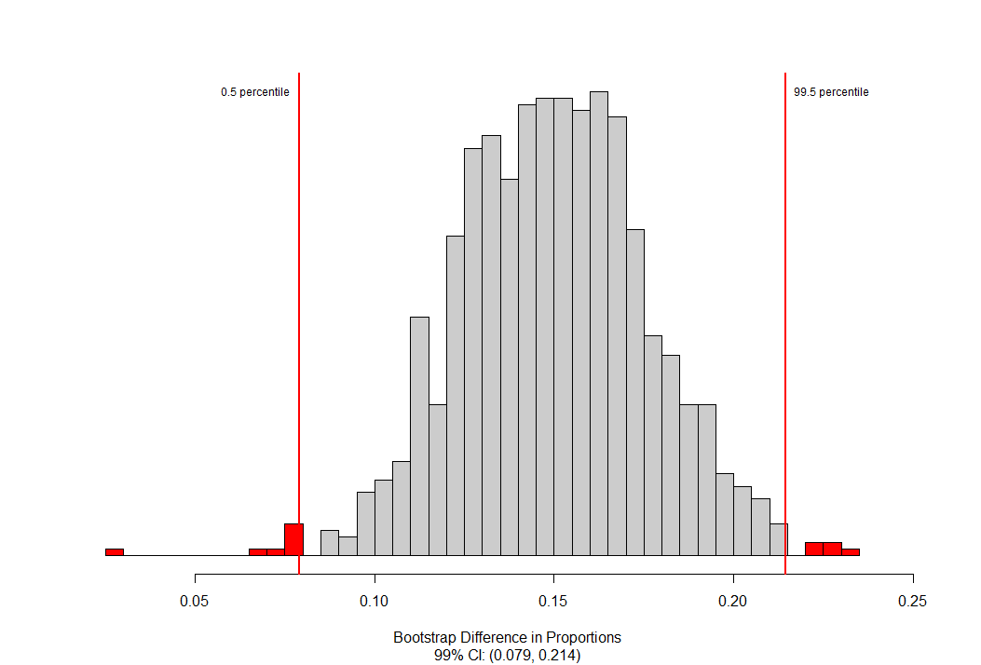Below is the bootstrap distribution for these data. Where is the distribution centered? Explain why that makes sense.

Center:

Explanation:

1. How much confidence should you have that the interval shown above, (0.079, 0.214), contains the parameter?
2. Based on this confidence interval, can we conclude that age **causes** the differences seen in perceptions of masculinity?
3. A recent Gallup poll reported that 77% of Americans are at least ‘somewhat’ confident in the government's ability to handle a coronavirus outbreak. A student researcher is interested if Montana State University students are more skeptical (less likely to feel confident) then what was reported in the Gallup poll. The student collected a convenience sample of 75 MSU students through an online poll and found 60% reported they were very or somewhat confident in the government’s ability to handle a coronavirus outbreak.

a) What is the most appropriate alternative hypothesis? Select one.

$π>0.60$

$π<0.77$

$π=0.60$

$π_{MSU}> π_{America}$

1. The student researcher is especially concerned about the possibility of a Type II error in the study. Interpret what a Type II error would be, in the context of this problem.
2. Are the conditions met to analyze these data? Be sure to check each condition and explain how you know the condition is or is not met in the context of the study.
3. If we were to repeatedly sample 75 MSU students from a population where 77% of MSU students were very or somewhat confident in the government’s ability to handle a coronavirus outbreak, how much would we expect each sample proportion to differ from 0.77, on average? Show your work and round your answer to three decimal places.

Work:

Answer: ___________

1. Calculate the standardized statistic from these data.

Work:

Answer: ____________

1. Interpret your standardized statistic in the context of the problem.
2. Can these results be generalized to all MSU students? Justify your answer.

* Yes, because the success/failure condition is met.
* Yes, because the sample size is large enough.
* No, because the sample is not likely to represent the population.
* No, because the proportion among MSU students is different than the proportion of all Americans.

1. Bozeman public school district plans to conduct a poll of parents in the district to determine views on the current requirement that students wear masks in school. They plan to lift the mandate if at least 2/3 of parents express a desire to remove the mask requirement. One district employee predicts that 75% of parents would want to remove the mandate. They want to ensure only a 10% chance of lifting the mask mandate when really 2/3 of parents want it removed. The employee also hopes to limit the probability of not lifting the mask mandate when really more than 2/3 of parents want it removed to 0.15.
2. What settings would be needed in the power applet to determine the required sample size?

Alternative Hypothesis (circle one): Two-Sided Less Greater

True Value of $π$:

Probability of a Type I Error ($α$):

Power:

1. Imagine that the sample size required with these settings is too large given the budgetary constraints of the district. Which of the following changes could the research make to the study to reduce the required sample size while maintaining the desired power of the test?

Change the Null Hypothesis Value to (circle one): 0.60 0.70

Change the probability of a Type I Error to (circle one): 0.01 0.15